Construction Planning Agent

  - Course Name: Btech CSE

Institution Name: Medicaps University – Datagami Skill Based Course

Student Name(s) & Enrolment Number(s):
Sr no | Student Name | Enrolment Number
1 | Hardik Baser | EN22CS301380
2 | Hricha Laad | EN22CS301429
3 | Huzefa Burhani | EN22CS301432
4 | Harshita Parmar | EN22CS301408
5 | Hariom Kale | EN22CS301381

Group Name:Group 02D4
Project Number:AAI-38
Industry Mentor Name: Mr Ashwin
University Mentor Name:Prof.Pradeep Baniya
Academic Year:2025-26

Problem Statement-
Construction Planning Assistant Agent

Project Objectives-
- To develop an AI-based assistant for construction planning
- To automate task breakdown and workflow generation
- To assist in resource estimation and scheduling
- To improve decision-making using intelligent recommendations
- To reduce manual effort and planning errors

Scope of the Project
- Focus on planning phase of construction projects
- Covers task generation, sequencing, and basic estimation
- Supports user queries like:
- “Generate construction plan”
- “Estimate resources”
- “List permits required”
- Limited to digital simulation (not real-time field integration)

Proposed Solution
- Key features
• Automated construction plan generation
• Task breakdown and sequencing
• Resource and material estimation
• Permit and compliance suggestions
• Interactive query-based assistant
• Error handling and fallback responses
- Overall Architecture / Workflow
2.1 Process Flow
1. User enters construction goal
2. Request sent to FastAPI backend
3. Planner Agent generates structured plan
4. RAG fetches relevant knowledge
5. Scheduler Agent creates timeline
6. Final output returned to user

2.2 Overall Architecture / Workflow
- User Input
  - User enters query (e.g., “Plan a residential building”)
- Planner Agent

Breaks down request into structured tasks.
- LLM Processing
  - Generates intelligent responses and plans
- Tool Invocation
  - Calls tools (if needed) for:
    - Estimation
  - Stores previous interactions for better responses
    - Data retrieval
- Final Output
  - Structured plan returned to user via frontend
Flow Diagrams
- Use Case diagram
The Use Case Diagram represents how different actors (users and external systems) interact with the Construction Planning Assistant System. It shows:
- What actions the system performs
- Who interacts with the system
- How the workflow moves from input → processing → output.

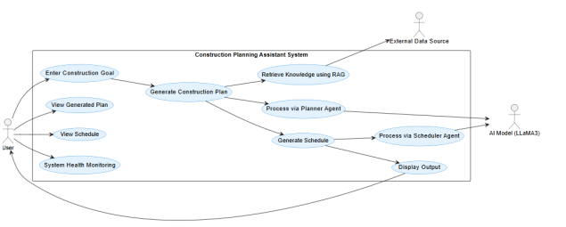

DFD Level 0 (Context Diagram):
This diagram shows:
• Entire system as one process
• Input from user
•Output to user
• Interaction with AI and RAG Flow:
1. User gives goal
2. System processes using AI
3. System fetches knowledge using RAG
4. Final plan & schedule returned

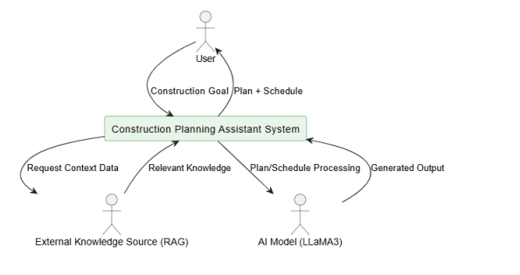

DFD (LEVEL 1):
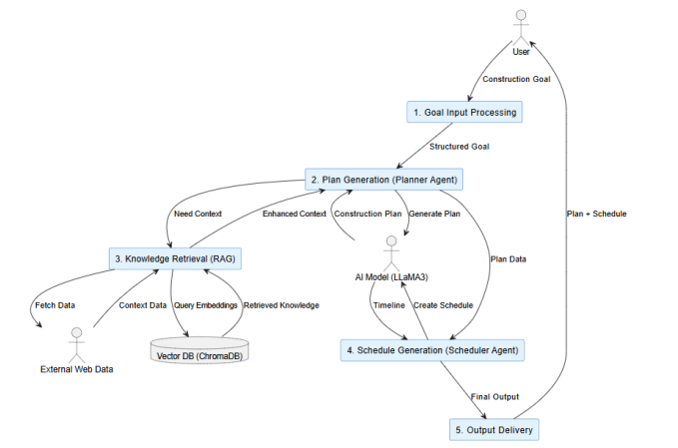

3.Tools & Technologies Used
• Frontend: Html,CSS,JS
• Backend: FASTAPI
• AI Model: LLM (via Groq / LiteLLM)
• Version Control: Git & GitHub
• Deployment: Vercel (frontend), local/server backend

Results & Output
- Screenshots / outputs

  - User Interface
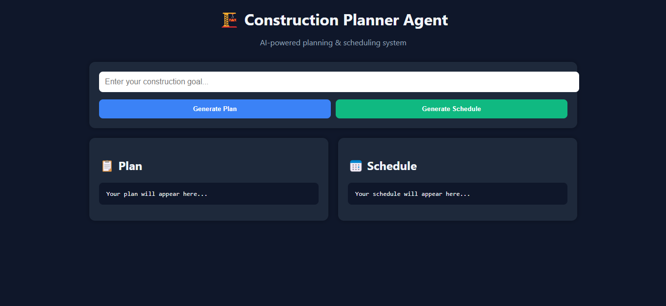

2.Key outcomes
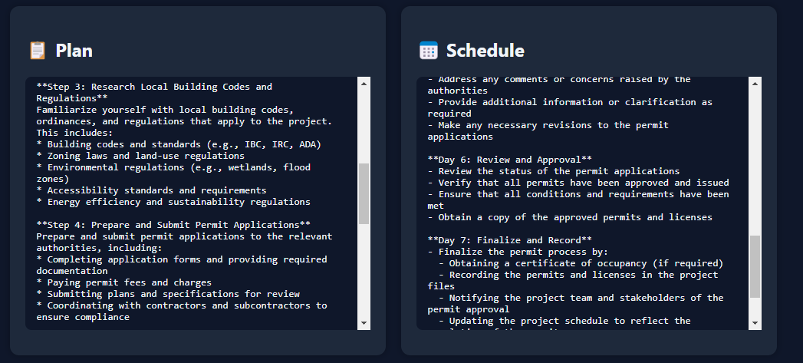

Conclusion
The Construction Planning Assistant Agent demonstrates how AI agents can simplify complex workflows in the construction domain. The project successfully integrates modern web technologies with AI to automate planning tasks, improve efficiency, and provide intelligent recommendations.
This project helped in understanding agent design, API integration, and real-world AI applications, making it a strong foundation for future intelligent systems.

Future Scope & Enhancements
• Integration with real-time construction data
• Advanced cost estimation using ML models
• Multi-agent system (planner, estimator, validator)
• Real-time collaboration features
• Predictive analytics for risk and delays

